

UHY member firm social media pack

Sample international content to use online and through social channels

publication of uhy global magazine issue 21

The 21st issue of UHY Global magazine is now available! Launched at the beginning of our 40th anniversary year, our flagship magazine is a real celebration of our collaborative culture, our people and our clients.

To support the release of the latest magazine, we have produced a short blog which you may wish to use on your website, together with some sample social media channel posts, to help you strengthen your international credentials and membership of UHY, the network for doing business.

We’ll also promote the launch on LinkedIn, Instagram and Facebook – please feel free to share these posts.

Printed copies of UHY Global issue 21 will be distributed to member firms around the world when available. Meanwhile, the PDF edition is now available to read and download here .

In addition to the usual mix of features and news, UHY Global issue 21 has:

- A special feature on football economics ahead of this summer’s World Cup
- Cogs & Wheels on our leadership development programmes
- Service feature on global mobility
- The latest member firm directory
- Listing of UHY service





PLEASE FOLLOW UHY INTERNATIONAL ONLINE

How to promote the blog

1. You can post the blog on your own website, in your international section, your blog or news. The full text is available at the end of this document.

2. You can make the link to the UHY Global issue 21 PDF edition available on your website or link to it from the blog. Alternatively, link directly to it on the UHY international website.

3. If you promote your member firm through social channels, you can link back to the blog or directly to the online PDF magazine. Here are some post suggestions:

POST 1
As we begin celebrations for UHY’s 40th anniversary we’re thrilled to introduce the 21st issue of UHY Global magazine, which is available to download now. We welcome World Cup year with a fascinating look at football finance, dig into the murky world of forensic accounting and follow the flow of investment in Central America, all with insights from our member firm experts. Plus a full UHY service summary, directory of our member forms and much more.
https://www.uhy.com/insights/uhy-global-issue-21

POST 2
Leaping in to our 40th anniversary year we’re delighted to launch the latest issue of our international business magazine, UHY Global. Our member firm experts grapple with some of today’s pressing business topics – including FDI in Central America and Mexico, the growing use of global capability centres, the world of football finance and the growing demand for forensic accountants. Plus our regular service features, celebrations of UHY people and global directory of member firms. Read it here https://www.uhy.com/insights/uhy-global-issue-21

POST 3
As UHY begins celebrations for our 40th anniversary, we launch the 21st issue of our flagship business magazine, UHY Global. This edition includes business insights and features ranging from football to foreign investment to fast fashion – plus our regular service summary, community pages and member firm directory.

Read it here https://www.uhy.com/insights/uhy-global-issue-21

Suggested hashtags:
#BusinessMagazine #Entrepreneurship #Markets
#BusinessInsights #Accountancy #BusinessGrowth
#B2BInsights #EntrepreneurGoals #GlobalBusiness

4. You can use this graphic for Facebook and LinkedIn or use graphics in your own style. The image below is for illustration only.

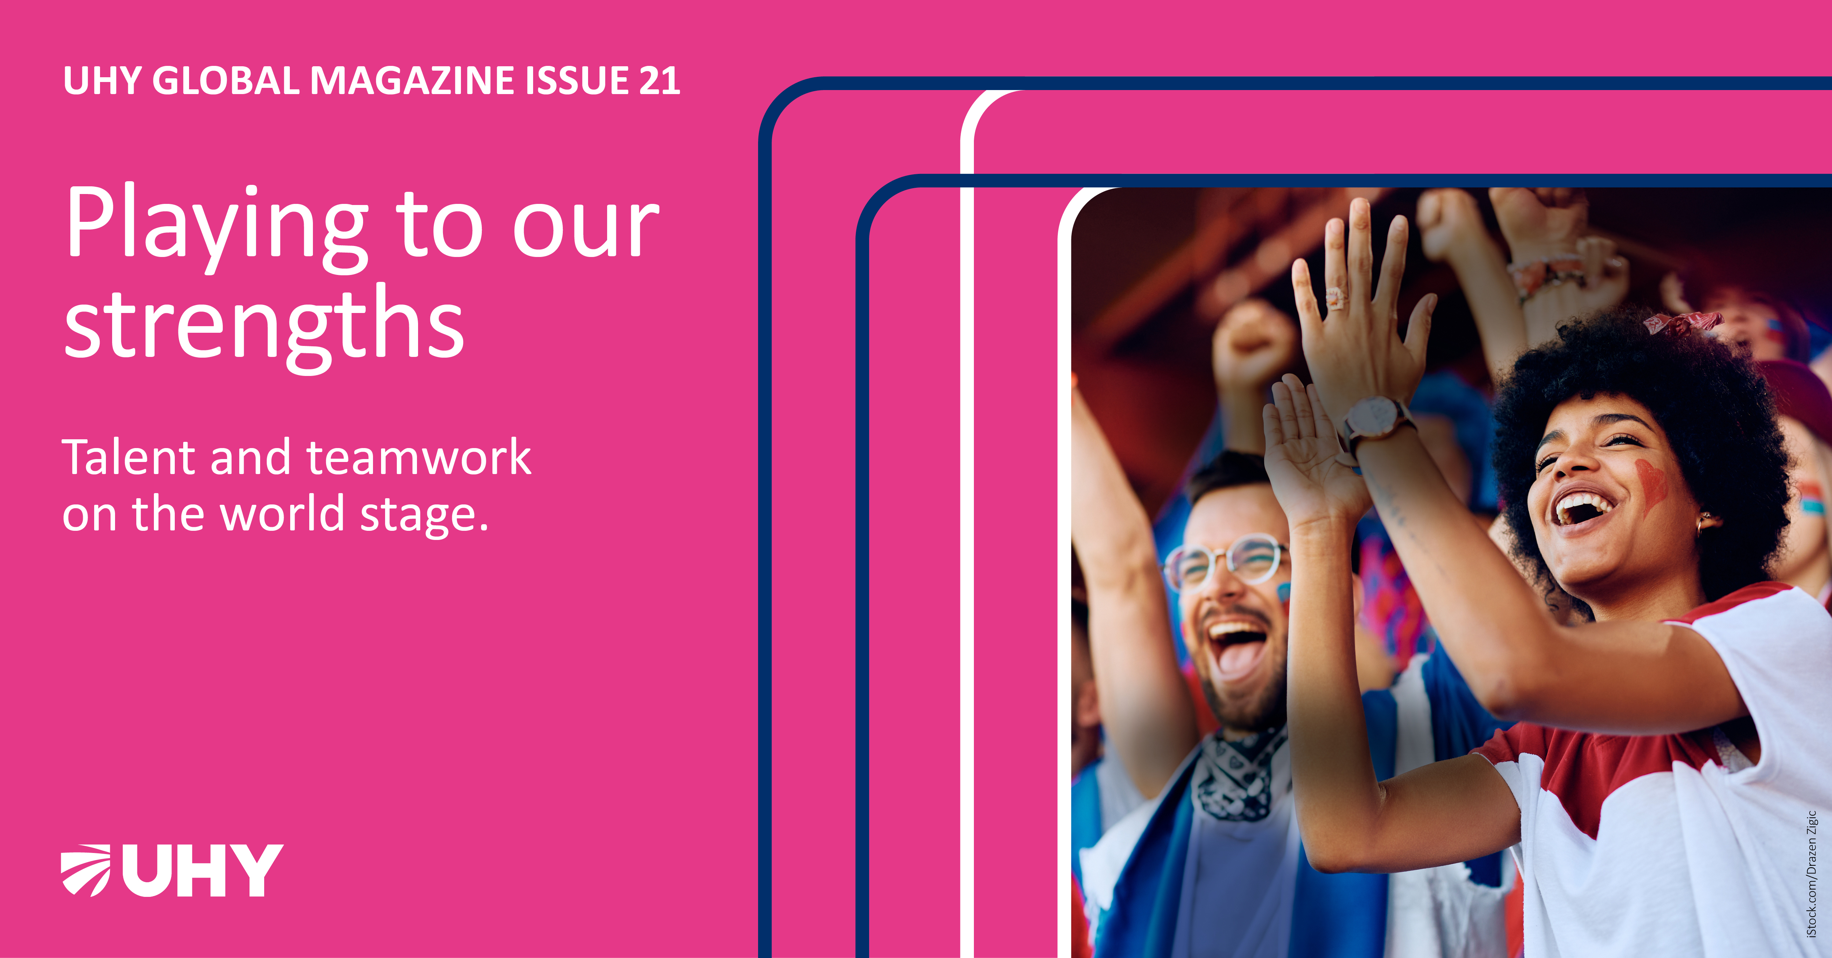

The graphics are available to download on our Exchange portal, LINKS BELOW:
LinkedIn/ Facebook 1, 2, 3
INSTAGRAM 1, 2, 3
X (Twitter) 1, 2, 3

Here is the blog text in full

NEW LOOK UHY GLOBAL MAGAZINE ISSUE 20 AVAILABLE NOW
The 21st issue of UHY Global magazine is now available to read online. UHY’s international business magazine includes analysis and commentary from the unique perspective of UHY’s member firm experts across the international network, to provide news, interest and insight for today’s global business community.

Our latest issue of UHY Global falls at the beginning of UHY’s 40th anniversary year, and we will be marking this remarkable milestone at our Annual Conference in October 2026 in the US. Ahead of that event, the 21st issue of UHY Global celebrates the collaborative spirit, commitment and shared values that UHY was founded on.

Included in this issue: awaiting this summer’s international men’s FIFA World Cup we tackle the fascinating world of football finance, with commentary from our member firms about the opportunities and risks. And amid the alarming growth of cybercrime, financial misconduct and digital fraud, we also put the growing discipline of forensic accounting under the microscope.

Our feature Capable Moves examines the rise of corporate global capability centres and their impact on issues such as the skills shortage as well as their vital strategic value for international businesses and countries. Another feature looks at how foreign direct investment (FDI) opportunities are opening up in Central America and Mexico.

The ever-important topic of global mobility is the subject of our service feature, looking at how businesses are navigating the complexities of cross-border workforces, taxation, and regulatory compliance. We also examine leadership and people in our regular Cogs & Wheels slot – how UHY is building tomorrow’s leaders and forging stronger collaboration across the network.

Plus our regular round-up of global news and a celebration of people and firms across our network, as well as information on the UHY network itself including a service summary and members’ directory. The print version is downloadable as a PDF from the online menu bar.

Read it now

----------------------------------------

